[Binary releases - Code::Blocks (codeblocks.org)](https://www.codeblocks.org/downloads/binaries/)

|  |  |
| --- | --- |
| codeblocks-20.03mingw-setup.exe | [**FossHUB**](https://www.fosshub.com/Code-Blocks.html?dwl=codeblocks-20.03mingw-setup.exe) or [**Sourceforge.net**](https://sourceforge.net/projects/codeblocks/files/Binaries/20.03/Windows/codeblocks-20.03mingw-setup.exe) |
| **Step 2 Install MinGW** |  |

[MinGW - Minimalist GNU for Windows download | SourceForge.net](https://sourceforge.net/projects/mingw/)

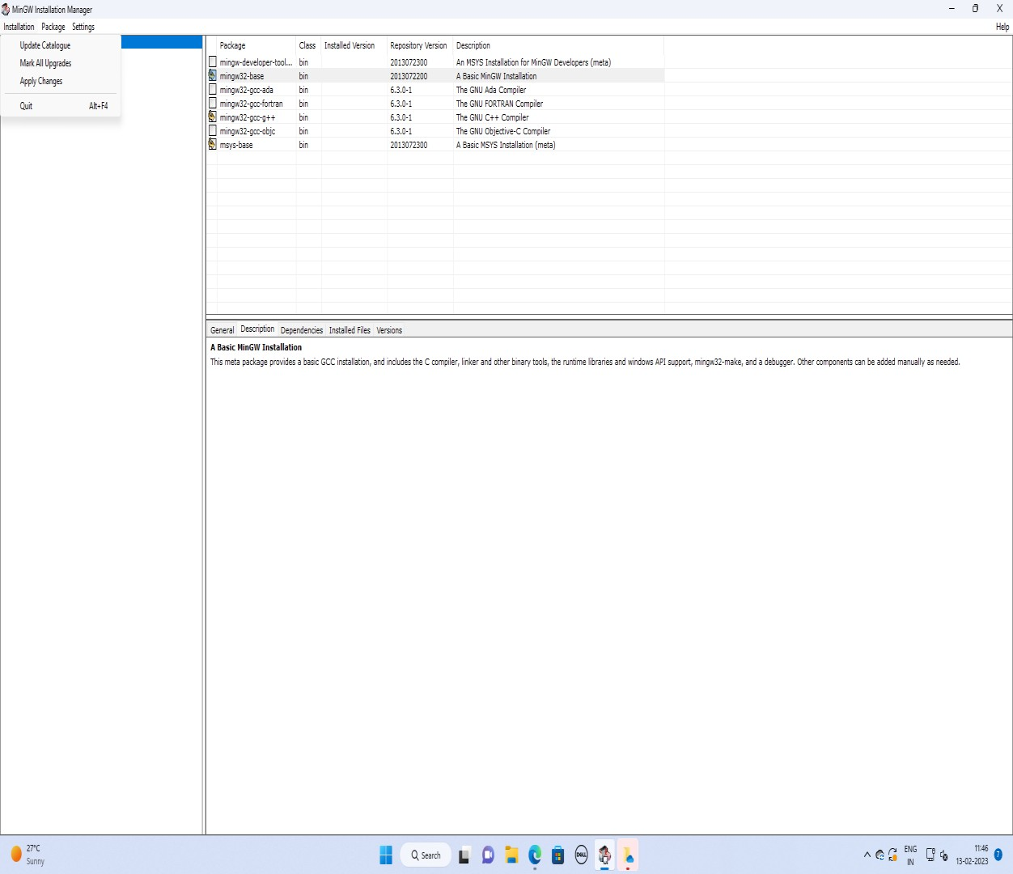

After selecting the above packages click on ‘Apply Changes’

Go to Window Search, type ‘env’

Click on ‘Edit environment variables for your account’ Add PATH ‘C:\MinGW\bin’

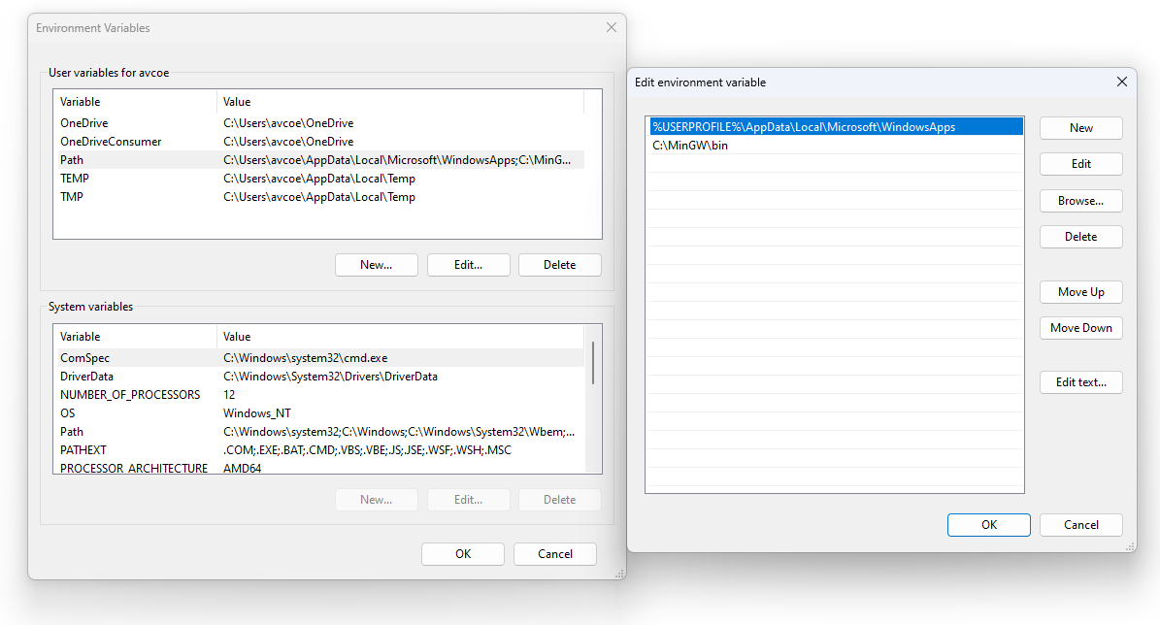

Step 4 Open Command Prompt

Check whether the gcc and g++ are properly installed or not

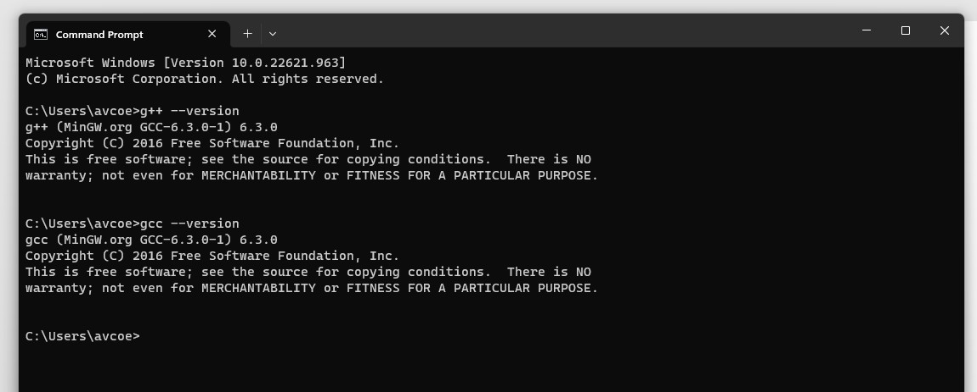

Go to Settings->Compiler->Other Compiler Options-> Type ‘-fopenmp’

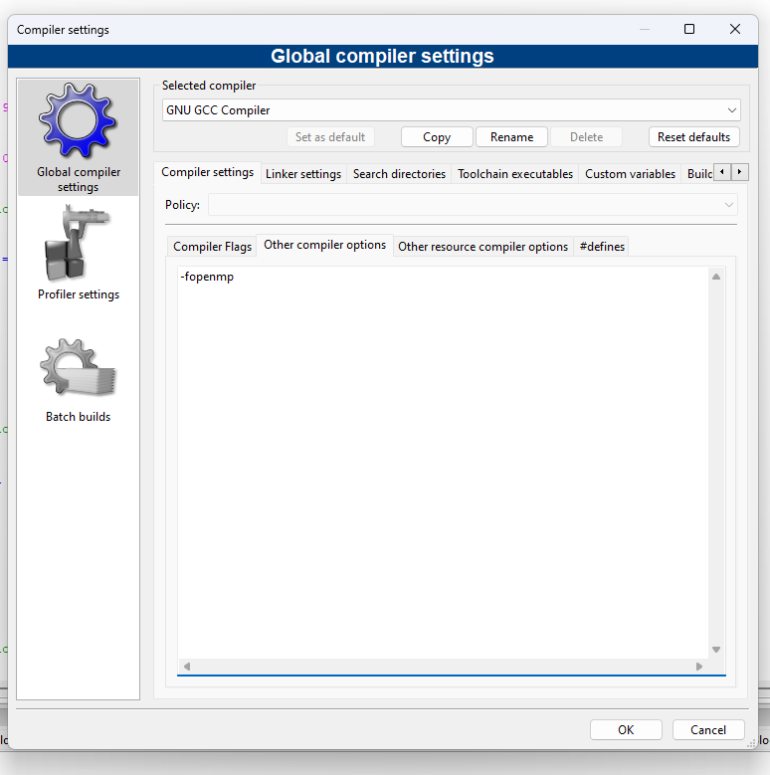

Add these path (for OpenMP)

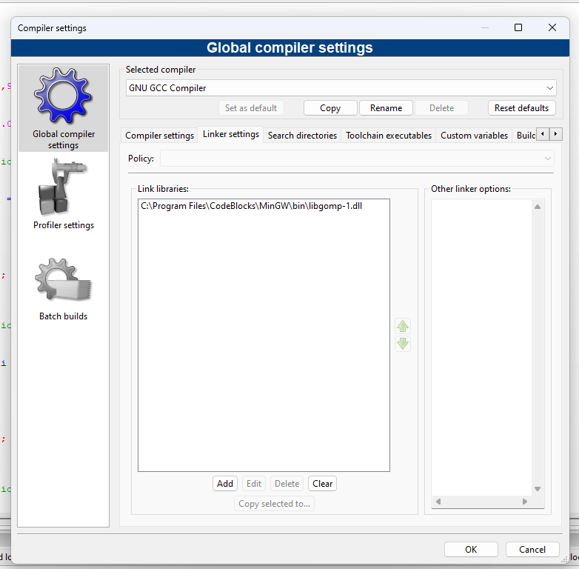

Now create file with extension .cpp or .c and compile and run !